CST8276 – Advanced Database Topics: Lab Assignment 1

Student Name: Jake Elliott
Student ID: 040732505
Student email: elli0449@algonquinlive.com

Hand-in:

- The lab assignment will be graded out of a maximum 2 points.
- This template should be used to submit your lab assignment.
- Make sure you have enough screenshots to completely document that you have completed all the steps.

Activities (Steps):

- In this lab you will be using the Oracle (Version 19c) database management system, and Oracle SQL Developer (Version 3.2). The first step is to get the software installed.
  - Download Oracle 19c.
    - Navigate to:
https://www.oracle.com/ca-en/database/technologies/oracle19c-windows-downloads.html
    - If this is your first time downloading Oracle materials, you will need to create an account – no cost. IF you have trouble with creating the account; it could be your browser; try Microsoft Edge. OR try signing in to your (new) account before clicking on the download links below:
    - Then download
WINDOWS.X64_193000_db_home.zip
    - And download these interesting examples
WINDOWS.X64_193000_examples.zip
- Create an Oracle installation folder, using a folder name that is short and does not contain blanks. (e.g., D:\oracle19cinstall) Then, unzip (that is, ‘Extract Alll…’) the two Oracle compressed files into the same Oracle installation folder (not nested!)
- Open a “cmd” window as administrator (i.e., Select “Run as administrator”). Then, navigate in the cmd window to the folder (under your installation folder in step 2) where the setup.exe file has been unzipped. Then, run the following command.
      - On Windows 10: make sure you are running the command as administrator and use the following command line. You need to have changed the working directory to the directory where the setup.exe program was unzipped. (Don’t just click on it in Windows File Explorer!)
Here’s the command you need to use:
setup -ignorePrereq -J"-Doracle.install.db.validate.supportedOSCheck=false"

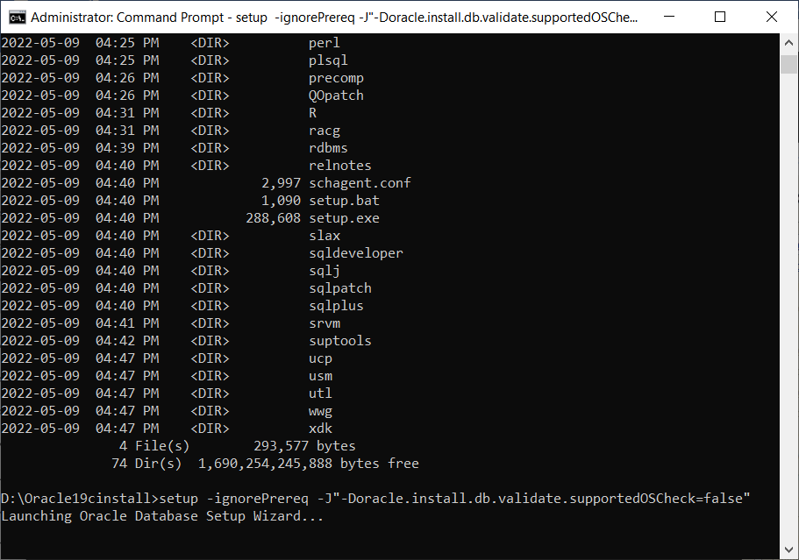
    - The installation program is a Java executable, and is notoriously tricky. Sometimes it will pop-up a window underneath the main window; leaving you waiting forever because you did not realize that the program is waiting for a response.
    - Respond appropriately to the installation customization queries. The critical steps are highlighted – they are mandatory for this course.
  - Step 1:
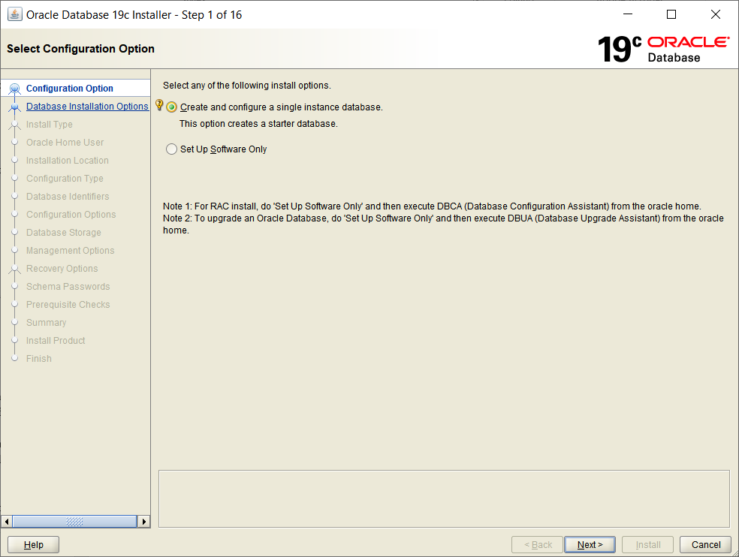
  - Click Next to get to Step 2: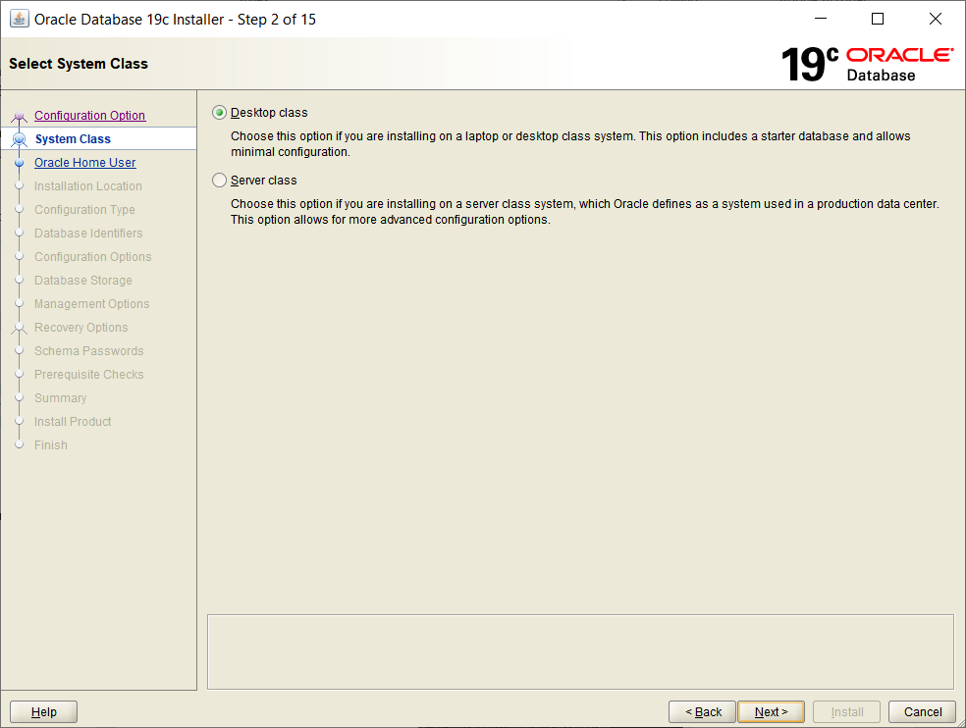
Select the Desktop class (the no-cost option)
  - Click Next to continue to Step 3:
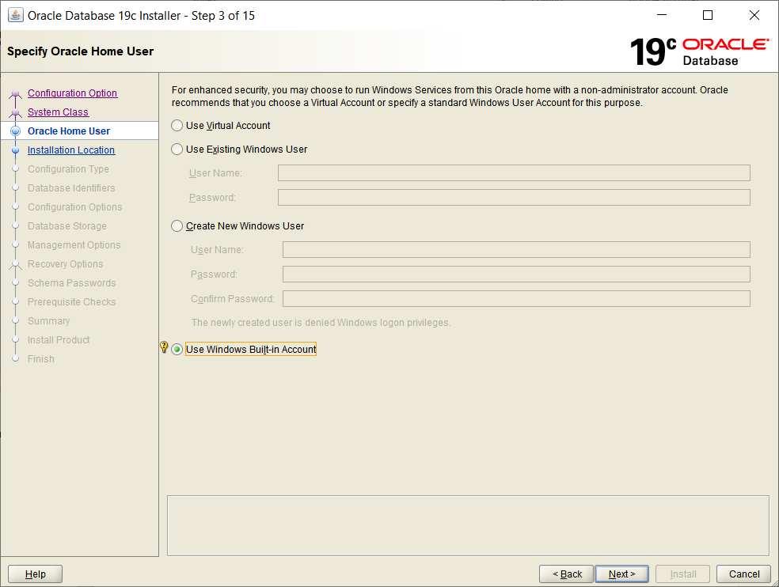
  - Select 'Use Built-in Windows Account, then press 'Next'
Ignore the security warning (likely) and say ‘Yes’ to proceed.
  - Step 4: Typical Installation Configuration:
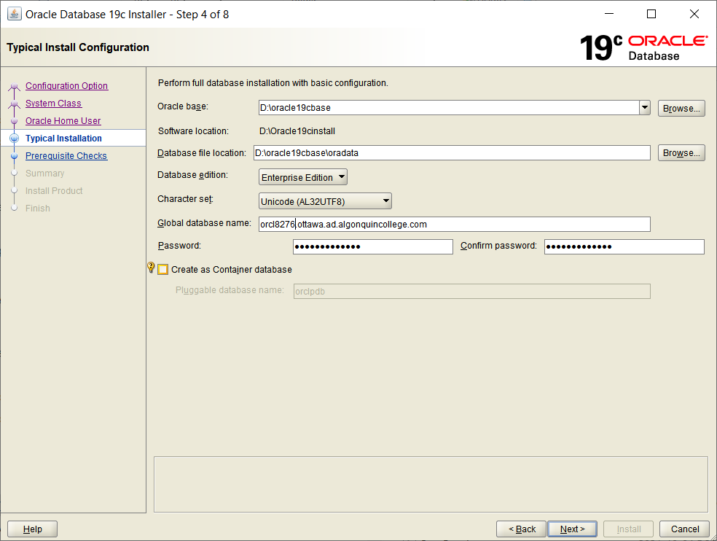
    - Note: you will need to make a screenshot before proceeding to Step 5 – don’t forget to do this before continuing after filling in this form for Step 4 (Suggest: use Alt-PrtScr which copies the active window’s image into the paste buffer and then just do Ctrl-V to paste each screen shot into the boxed areas below.)
      - Accept defaults EXCEPT for the following:
        - You will need to create an empty directory to be the new Oracle base. Then use that directory name for the Oracle base: field value.
        - If you have previously installed Oracle, you may need to change the global database name from the default ‘orcl’
        - CAREFUL: Make sure to uncheck the ‘create as container database” checkbox
        - Admin (SYS) password: 'yourFirstNamesOracle123' (e.g., dougOracle123)
        - If you receive a warning('INS-30011') that your password strength is poor, ignore it
        - 'Next' / 'Yes' to continue
      - Now create your screenshot showing your configuration values for this step and paste it below:
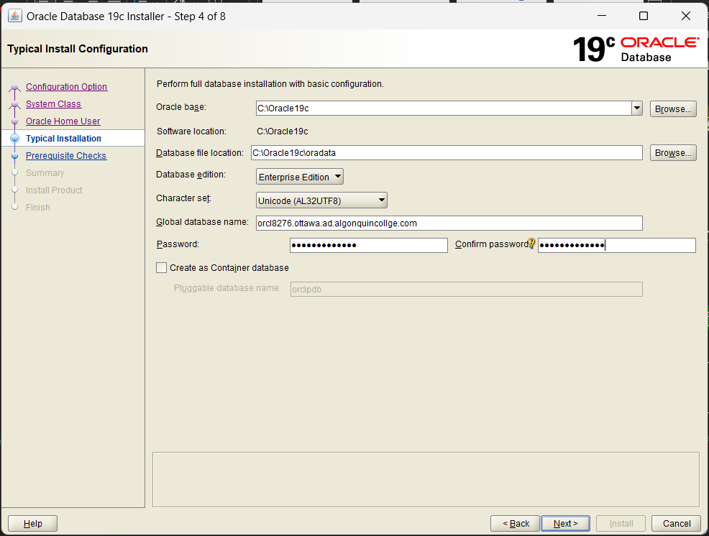

  - Step 6: Note: when you proceed from Step 4, the pre-requisite check (which would be step 5) should be skipped, and the number of steps will now likely be 8 (if you ran the setup file with the correct option to not handle pre-requisites). It depends upon the past Oracle installation history on your computer. The expected next screen is:
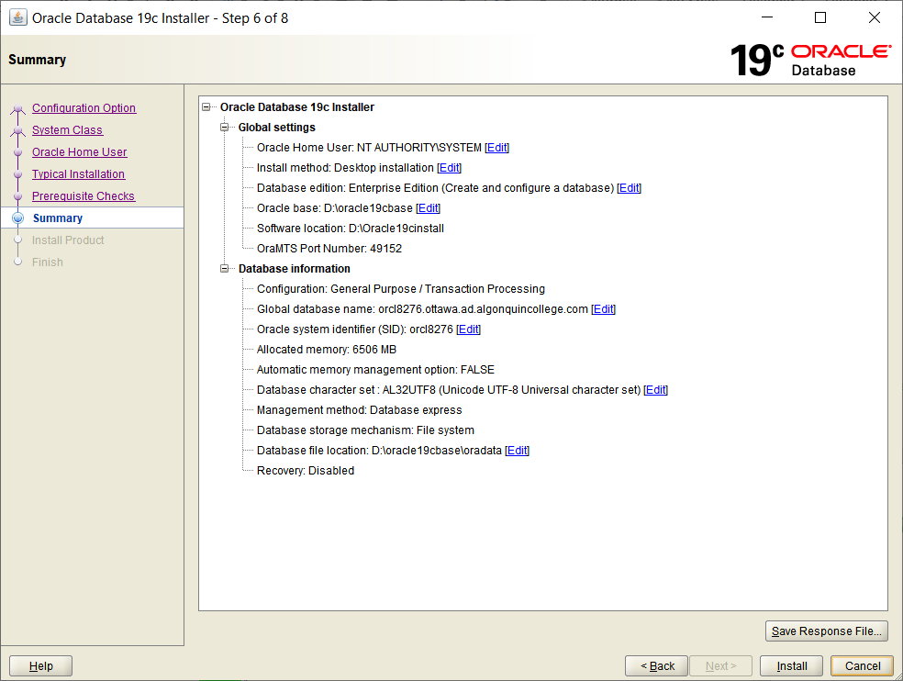
    - Select 'Save Response File' and then after saving it to the default location, Select 'Install'.
  - Step 7: The installer will now start installing ….. it takes some time!.
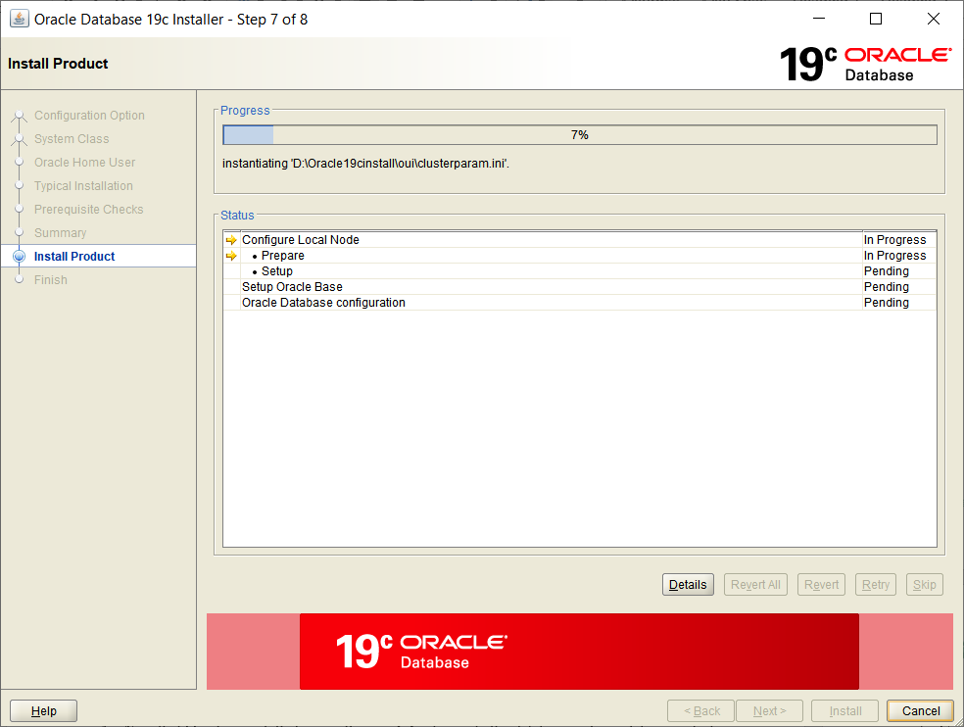
(There are several steps that may take minutes to show progress – even when showing the ‘Details’). If it seems to be really ‘hung’ look for a hidden pop-up window. ) If you receive a Windows Defender or other firewall message, allow access for Java.
    - Here is a screenshot of the progress Details part way through my installation just to give you some idea of what to expect. The entire installation could take over 30 minutes; it very much depends on your computer configuration and history of software installations.
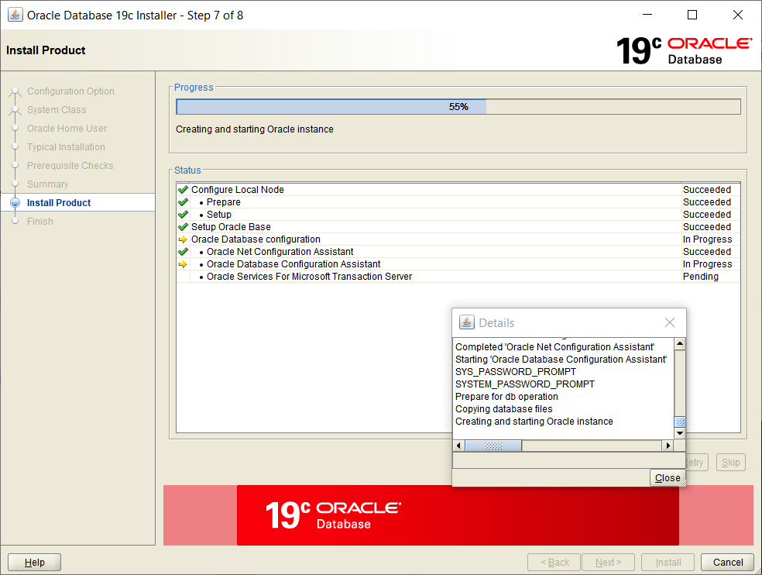…
    - All components for the enterprise edition should get installed, but there may be some pre-requisites missing (they will not be important for our course).
    - If you entered the admin passwords correctly earlier, then you should not be prompted to enter them again….If you are prompted, fix it as follows:
    - In the Password Management screen, change the password for user SYSTEM to : 'yourFirstNamesystem' (e.g., dougsystem). You may unlock and change passwords for some other accounts at the same time (or just leave them defaulted for now. The website https://www.orafaq.com/wiki/List_of_default_database_users
has a list of default Oracle usernames and default passwords.
    - Ignore any additional password standards warning message. 'Continue? Yes' / 'OK'
    - Windows 10: If Services for Microsoft Transaction Server cannot start – that is OK. Here is my error message:
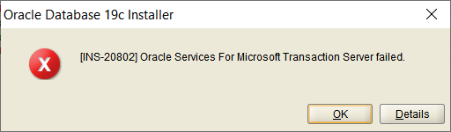
      - If you get this message, Click OK and Yes if asked are you sure you want to continue. The eventual ‘completion’ screen for me on Windows 10 is: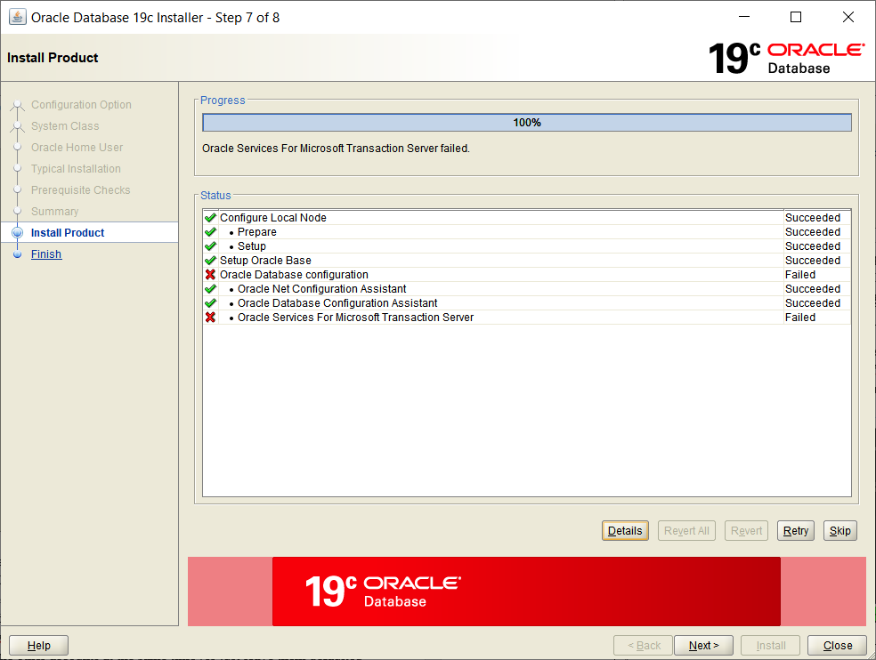
It indicates a ‘Failed” installation on Windows 10, but all should be OK for the database except for the missing interfaces to Microsoft distributed transactions. If you happen to have the Microsoft .Net tools installed on your computer, then you may end up being successful here; if prompted, you could opt to install missing pre-requisites.
  - Step 8: You will get an ‘Software Installation was Successful’ message displayed. (even for my case of missing Microsoft Transaction Services). You will need to take a screenshot – read all of 3.9 before proceeding to make sure you don’t miss your chance.

In my case I get a ‘confirmation’ popup that says: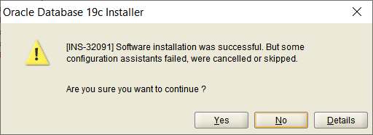
Which when I select ‘Yes’ to continue is followed by the confirmation screen: here is mine.
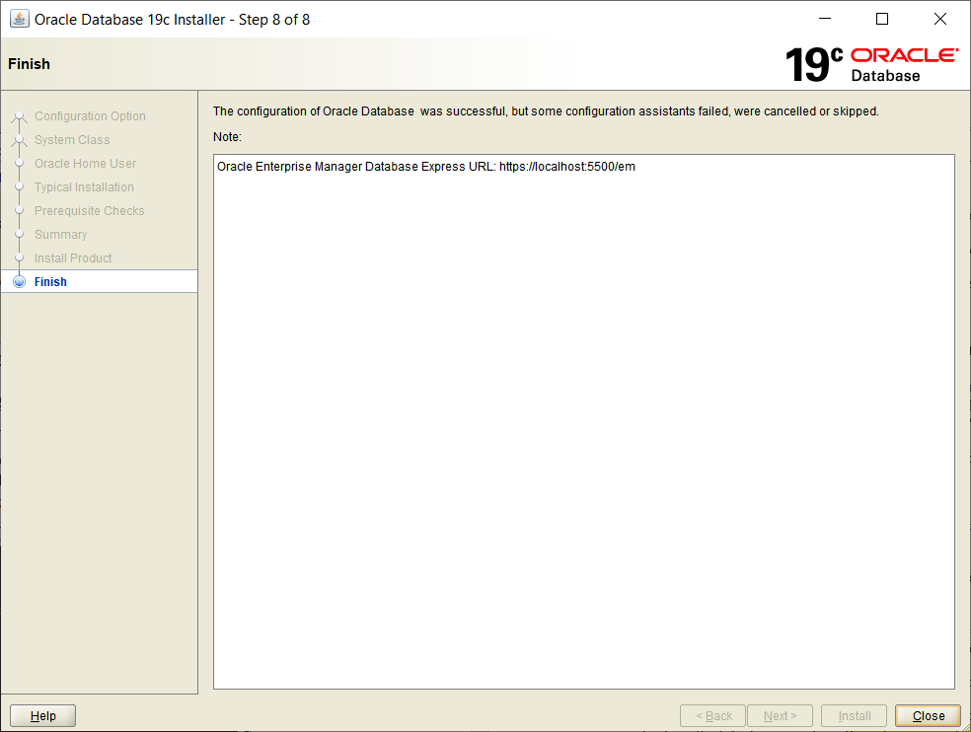
    - Take your screen shot for Step 8 before closing the window and paste it below Then, select 'Close'
    - Paste your screen shot showing ‘successful’ installation below.

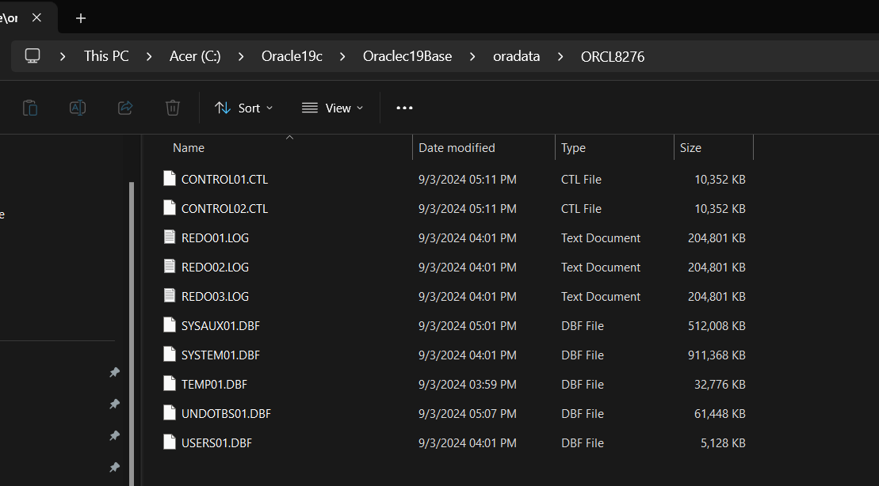

- Now we will confirm that all is actually OK.
  - Confirm you are able to connect to the database.
    - Open a new cmd window using ‘run as administrator’
(you need a new window to get a fresh set of environment variables)
    - run the ‘sqlplus / as sysdba’ command line.
    - Once connected, run the command ‘show con_name;’ which will show the connection name for your default instance. Here is mine:
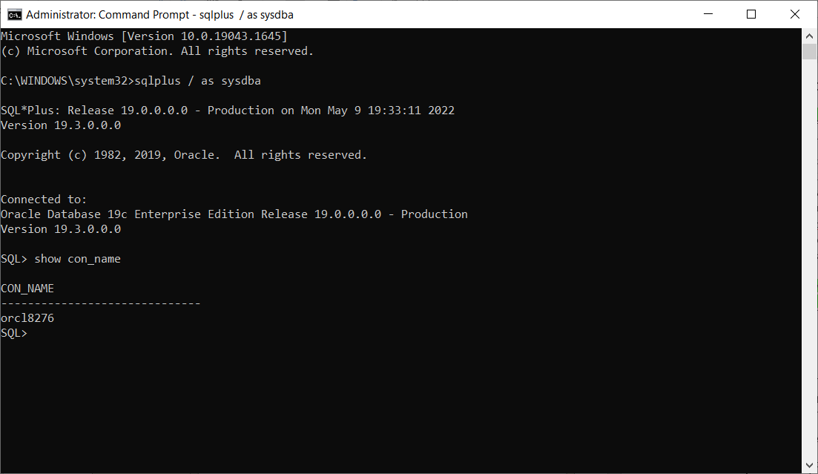
    - Now Paste your screenshot showing your command window with the connection name (database name) clearly visible along with the version:
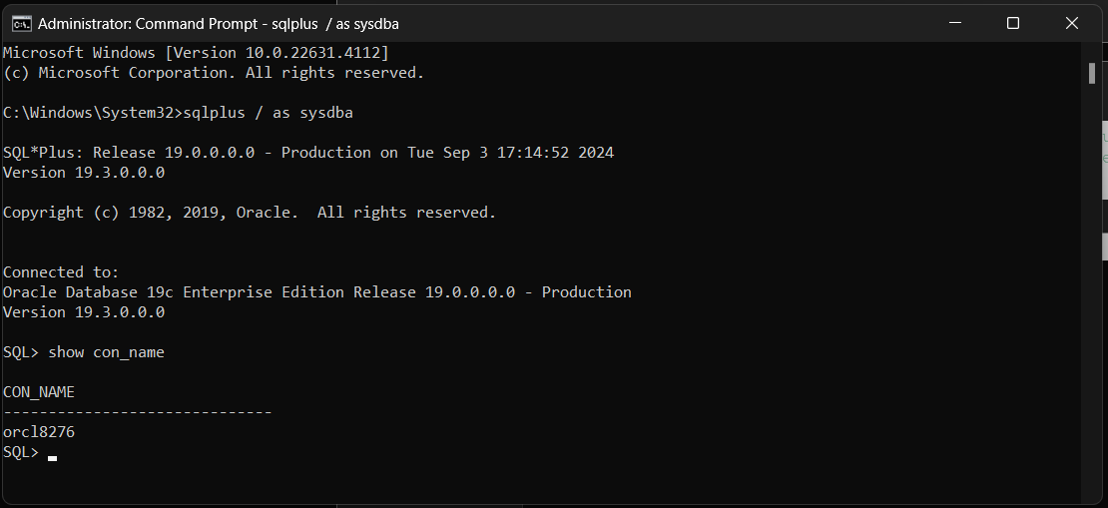

    - While still connected using ‘sqlplus / as sysdba’ run the command ‘select USER from DUAL;’ and show the screenshot below:
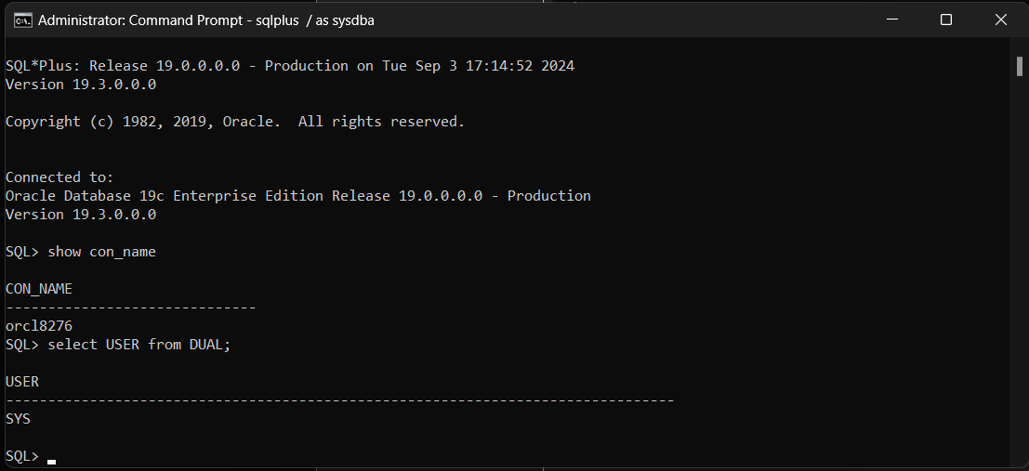
    - While still connected using ‘sqlplus / as sysdba’ change the password for SYS (Hint: use “alter user SYS ….”. Set it to “password” (Look up the syntax in the online ORACLE manuals). Provide a screenshot below

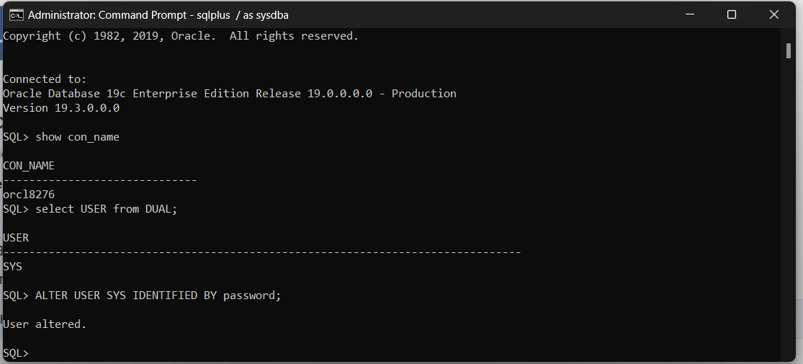

  - Search for the init.ora (pfile) text file in the Windows file system (it will be somewhere on your computer …) using the File Explorer and then copy a screenshot showing the file location and full name of the pfile text file to your submission document. Here is mine:
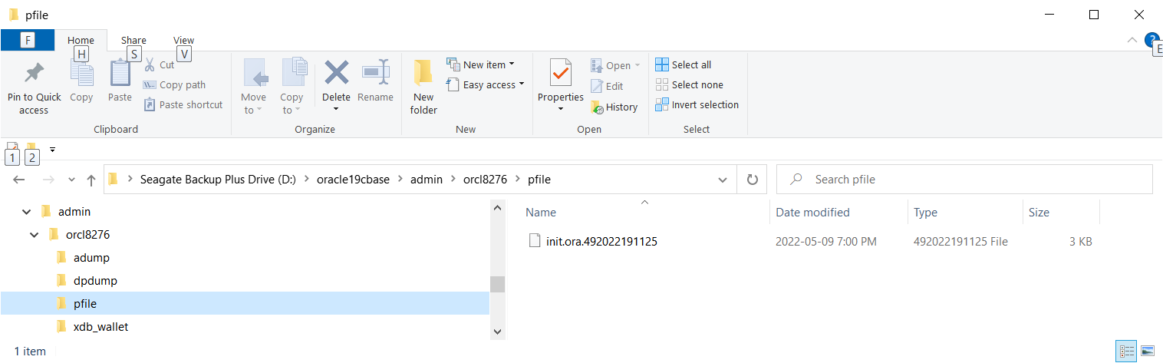.
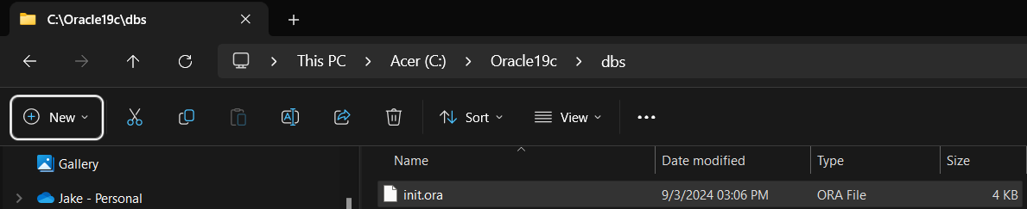

  - Make sure the below script can be executed without errors. Take a screen shot of the output. (Use a SQLPLUS command window).
CREATE TABLE sales01
(prod_id NUMBER(6)
, time_id DATE
, quantity_sold NUMBER(3)
)
PARTITION BY RANGE (quantity_sold)
( PARTITION sales_p1 VALUES LESS THAN (35)
, PARTITION sales_p2 VALUES LESS THAN (76)
, PARTITION sales_p3 VALUES LESS THAN (MAXVALUE)
);

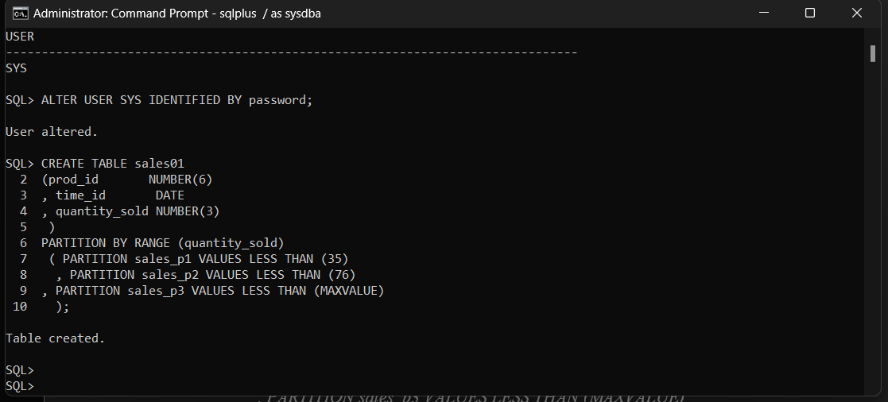

- Once you have embedded all of your screenshots, submit the file in Brightspace and you’re done!

